Student Mykhailo Soroka (TL_KCOMP_B_Y1)
T00287162
Lab 1: Booting the PC and Windows Interface

Lab 1: Booting the PC and Windows Interface

Part A – Looking at the BIOS/UEFI

- BIOS – systems that boot up and initializing hardware, running a Power-On Self-Test to check the components as CPU, RAM, and hard drives, finding and loading the operating system that installed on the
- UEFI – is replacement for the BIOS, but in modern way. It’s acting as a firmware that connects your computer’s hardware to the operating system.

BIOS

What is the BIOS version?

- BIOS Version - 1.22.0

List the main menu options of BIOS.

- Overview
- Boot Configuration
- Integrated Devices
- Storage
- Display
- Connection
- Power
- Security
- Passwords
- Update Recovery
- System Management
- Keyboard
- Pre-boot Behaviour
- Virtualizing Support
- Performance
- System Logs

CPU

What is the CPU speed?
- Minimum Clock Speed – 0.80 GHz
- Current Clock Speed – 5.04 GHz
- Maximum Clock Speed – 5.20GHz

What other information is listed for the CPU?
- Processor Type – 13th Gen Intel(R) Core(TM) i7-13700
- Processor ID – B0671
- Core Count – 8+8
- Microcode Version – 12C
- 64-bit technology – Yes

RAM

What is the RAM speed?
- Memory Speed – 4400MHz

What other information is listed for the RAM?
- DIMM 1&2 Size – 16384 UDIMM
- Memory Available – 32540 MB
- Memory Installed – 32768 MB
- Memory Technology – DDR5 SDRAM

BOOT

What is the first boot device in the boot order sequence?
- Windows Boot Manager

How many additional devices can be assigned in the boot order sequence?
Five

What happens when the computer boots and the first bootable device is not available?
If the first boot device is unavailable or not bootable, the system automatically moves to the next device in the boot order sequence, continues checking until a bootable one is found. If no bootable device is found, an error message such as “No bootable device found” is displayed

What are the requirements to enable Intel Trusted Execution Technology (TXT) in the BIOS?
- Intel CPU that supports TXT
- Intel Virtualization Technology (VT-x) enabled
- TPM (Trusted Platform Module) enabled and activated
- Secure Boot disabled (on many systems)
- BIOS Admin/Setup password configured (on some systems)

Can you discover what is the meaning of S.M.A.R.T. from the Storage menu?
SMART - Self-Monitoring, Analysis, and Reporting Technology
It is used to:
- Monitor the health of storage devices
- Predict drive failures before they occur

What options are available under System Management?
- Asset Tag
- Service Tag
- BIOS Downgrade
- Data Wipe
- UEFI Capsule Firmware Updates
- OS Recovery
- Auto On Time / Power Management setting

Part B – The Windows Interface.

Windows

2. Can you find out what version of Windows is running on your PC?

Version 24H2 (OS Build 26100.7623)

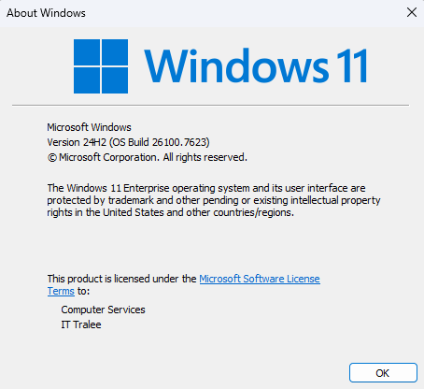

Computer Lock
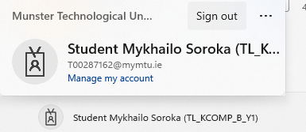

Changing the Look of the Start Menu

Personalization > Taskbar:
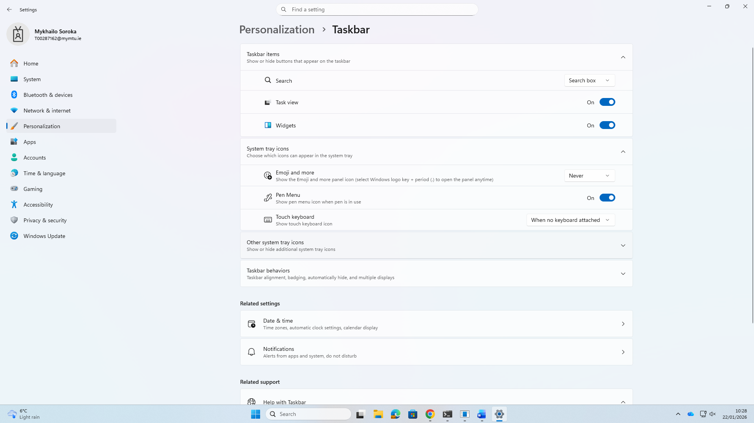

Personalization > Start:
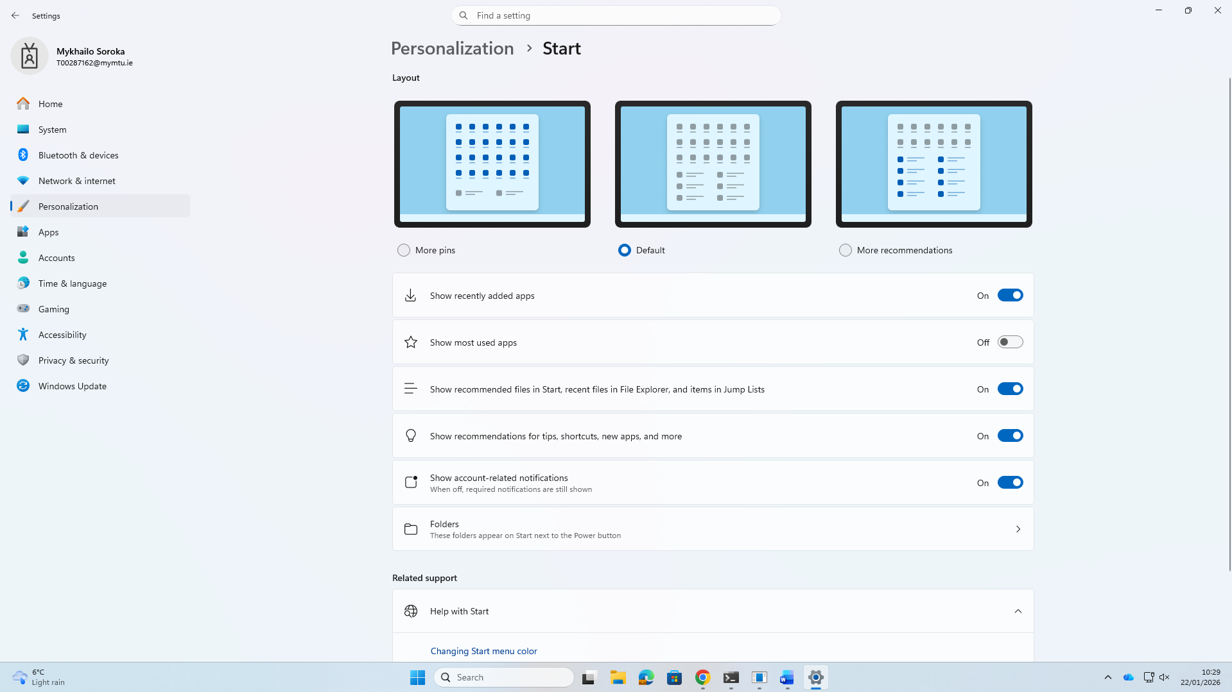

Changes:
Was:
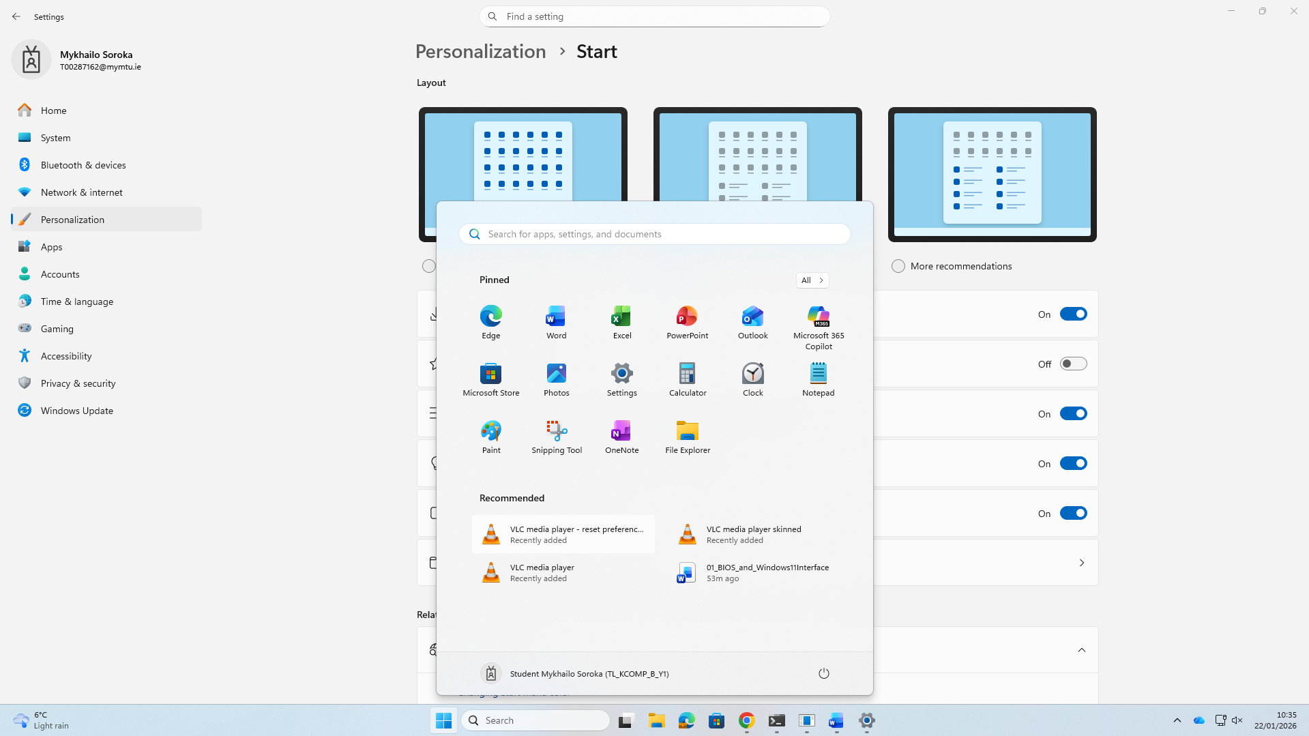
Became:
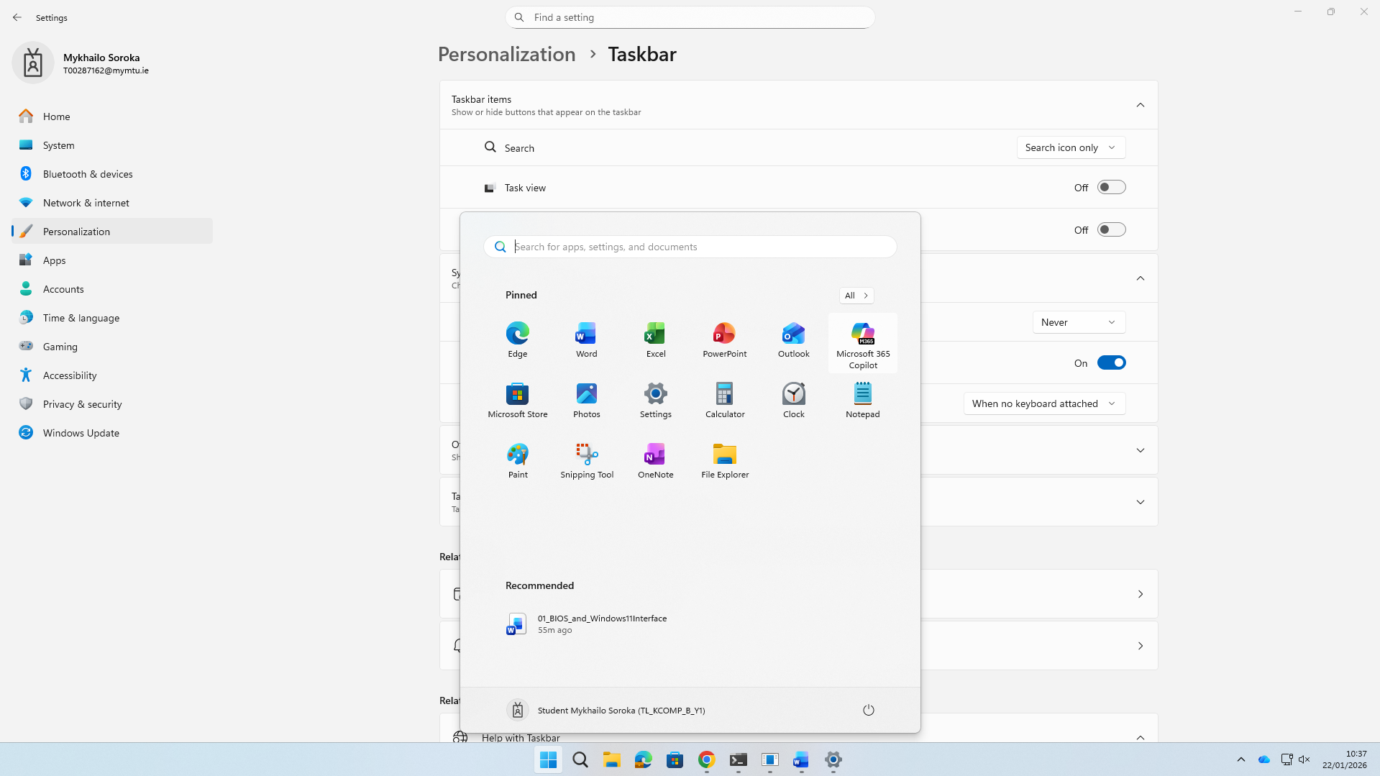
I added more pins over recommended apps, unable recently added files, task view, and widget, also pick “Icon only” for the search bar.

Finding your App with Task View:

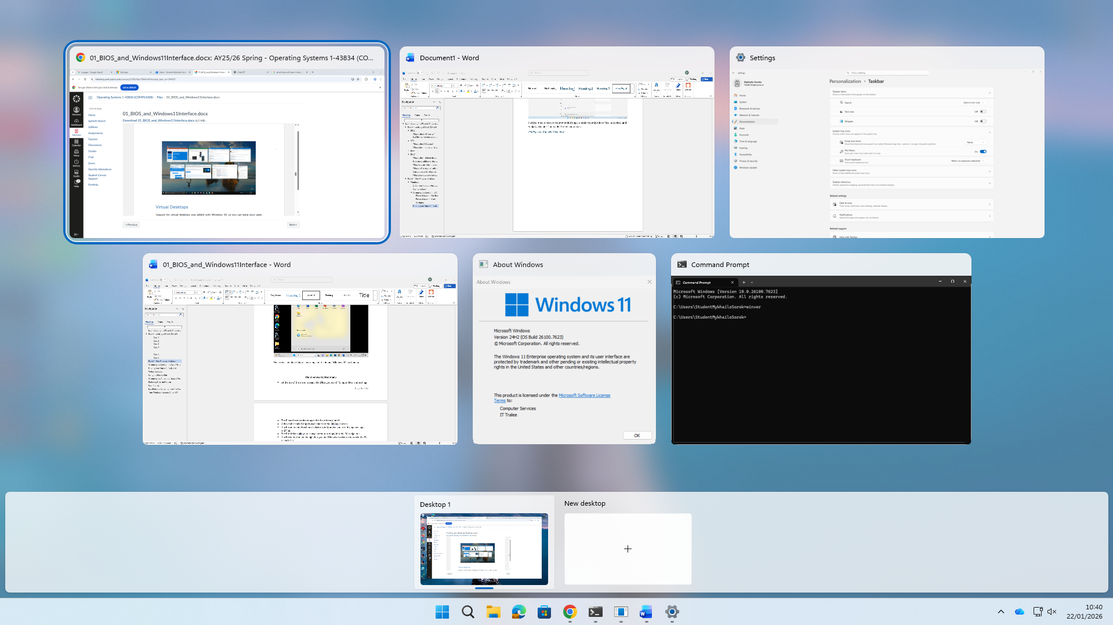

Virtual Desktops
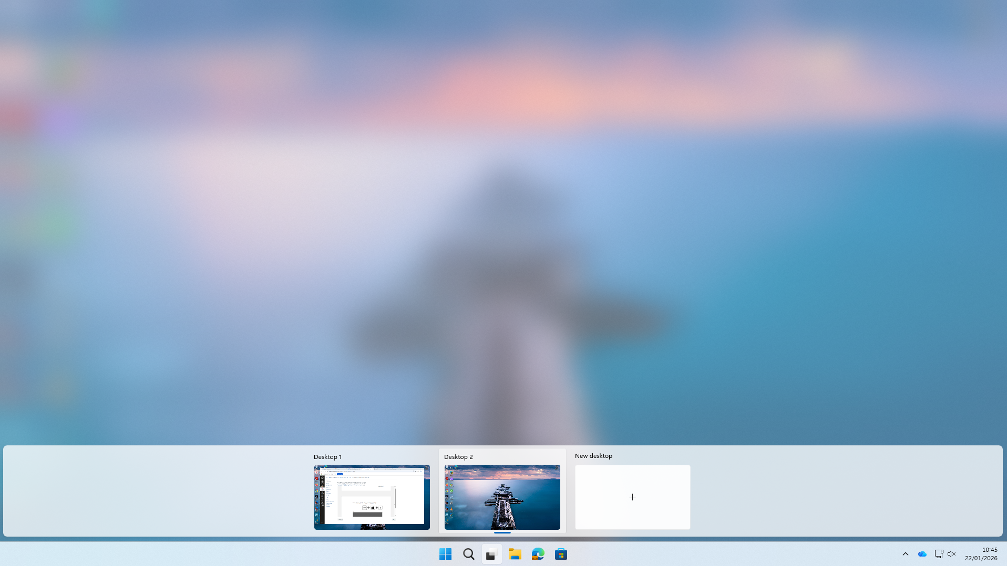

File Explorer

Folder Options
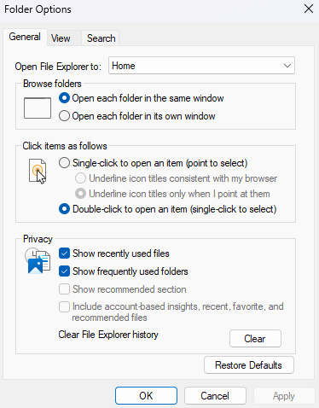

Recycle Bin

Delete premanently
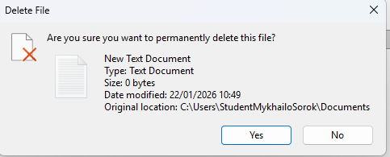

Changing the Amount of Space Allocated to the Recycle Bin
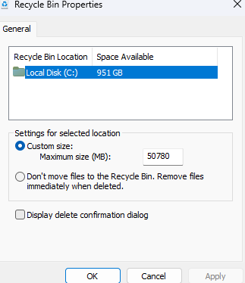

Storage Sense
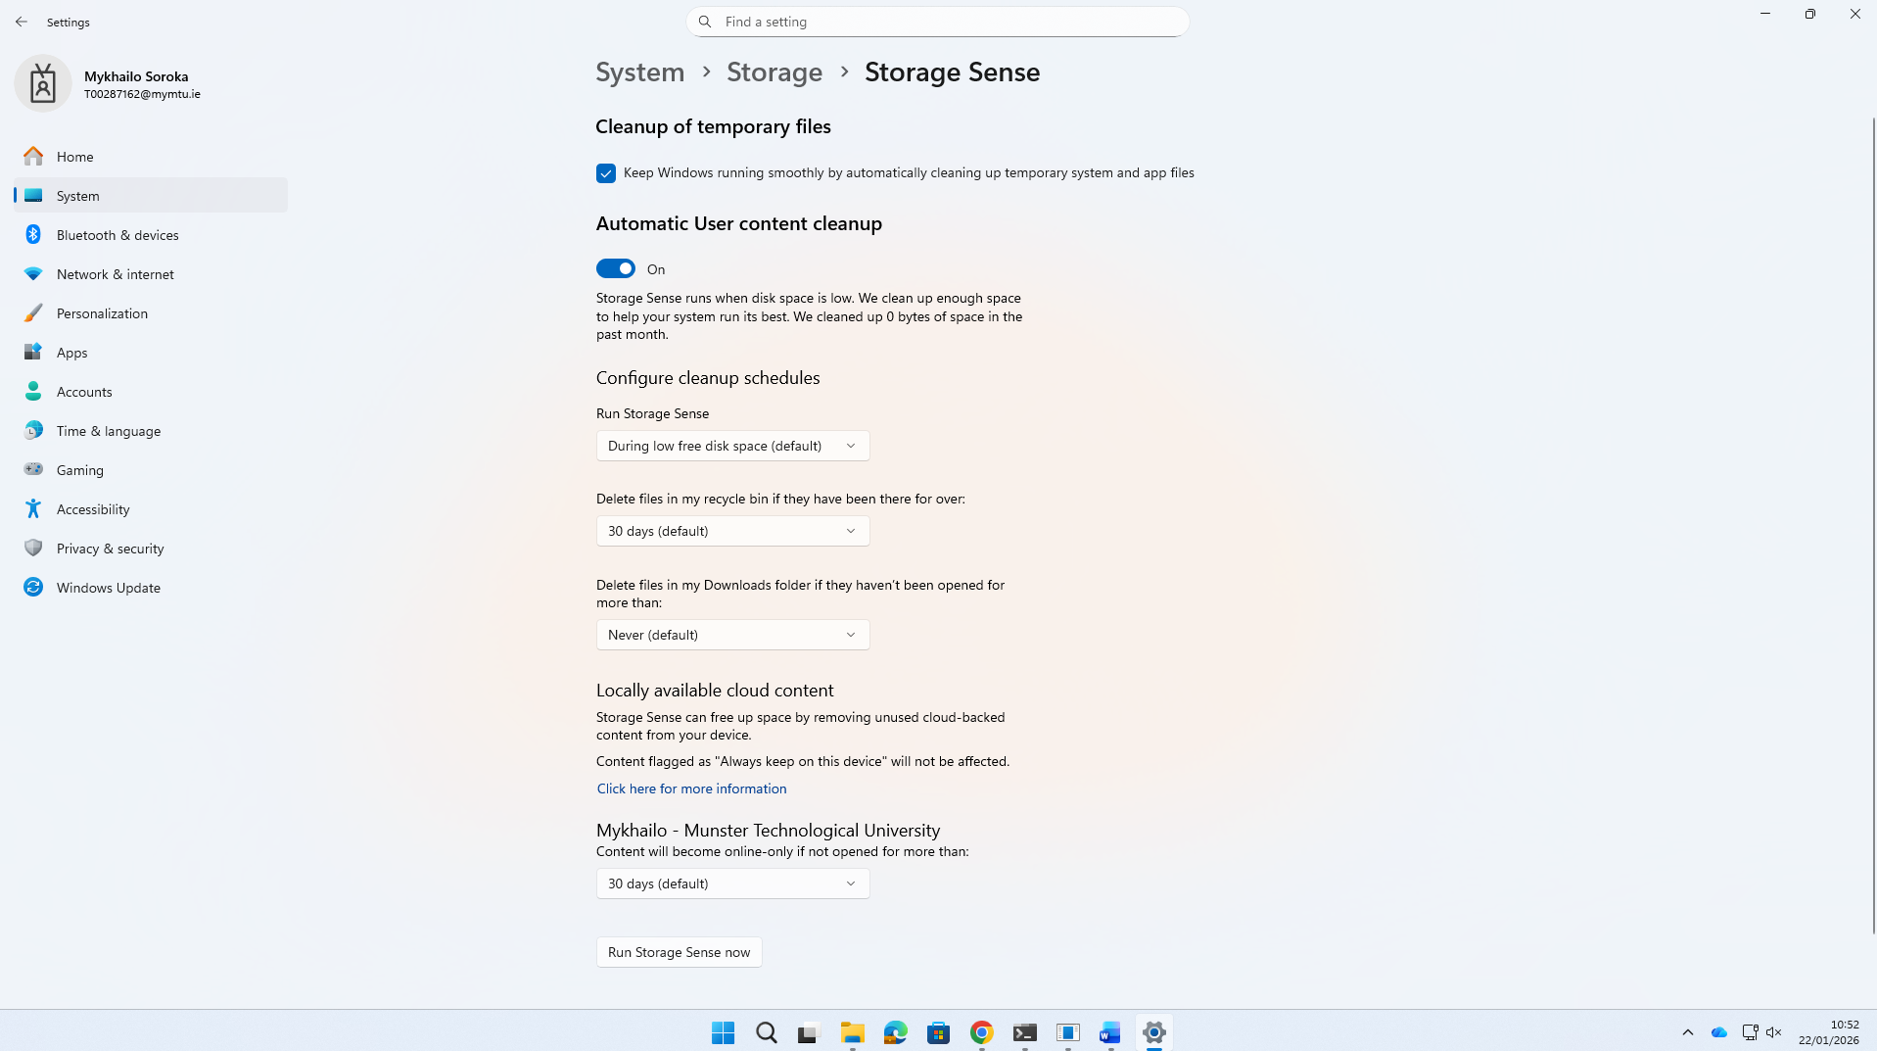

Restoring Files and Folders
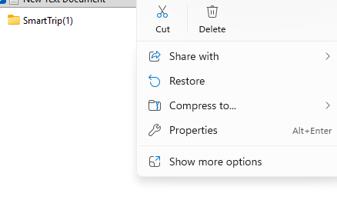
Location and Content of User Profiles
To do: Name any item that appears in the Desktop folder. Check that this is on your desktop
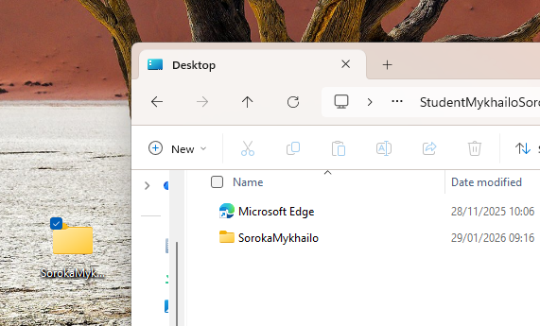

Turn Windows Features On or Off
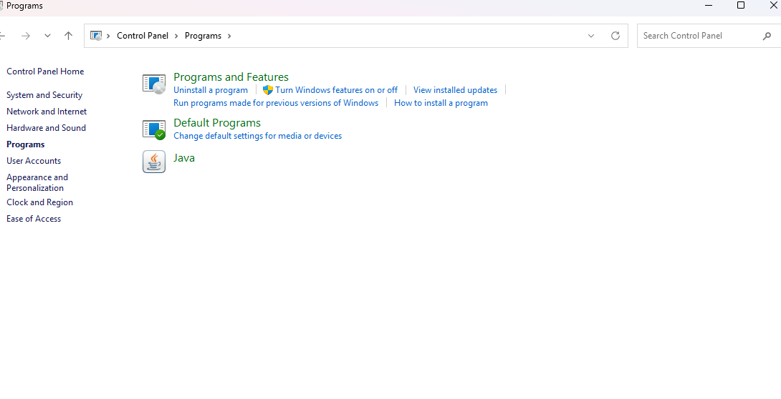
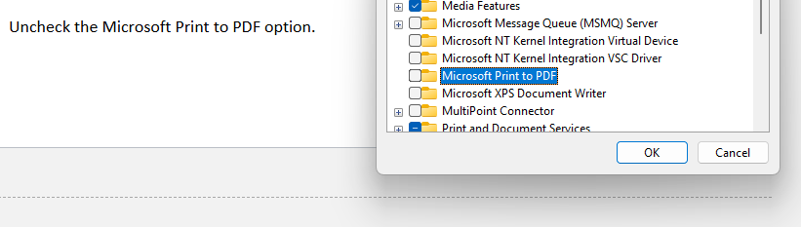
To do:
Use the msinfo command to discover the BIOS Mode setting on your PC.
Outline a method (other than that described in Part A) to access the BIOS from within the
Windows 11 interface.
Lookahead: Can you use Powershell to determine information about the BIOS version?
Get-CimInstance -ClassName Win32_BIOS
Get-CimInstance Win32_BIOS | Select-Object Manufacturer, SMBIOSBIOSVersion, ReleaseDate

